Hobbit: The Desolation of Smaug
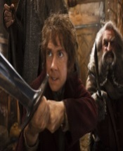
Who could guess, after the meandering first feature in a seemingly unnecessary eight-hour trilogy of films based on a novel of less than 300 pages, that Peter Jackson had such a vigorous and thrilling middle episode in store?

9. 12 Years a Slave
Southern whites of the pre-Civil War plantation aristocracy believed themselves God’s chosen and their slaves inhuman. As shown in this searing film document — an anti-Gone With the Wind — the masters were the madmen, inferior but in charge

8. The Act of Killing
In 1965, the thug Anwar Congo was hired by the Indonesian government to stamp out the threat of Communism; he and his fellow gangsters formed paramilitary squads that tortured and killed thousands of innocents. Nearly a half-century later, Anwar and many of his colleagues are still around, still protected by the politicians in charge, and ready to reenact their atrocities.

7. Frozen
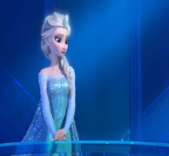
Princess Elsa has powers of sorcery beyond her control: she can and does cast a nuclear winter on her northern kingdom. Her sister Anna is the normal one, falling in love at the first sight of any eligible male, yet bound to confront her sister and save their realm.

6. Furious 6
Planes, trains and automobiles collide spectacularly in the fourth Fast & Furious movie to be directed by Justin Lin and written by Chris Morgan. In a reunion of Vin Diesel, the late Paul Walker, their gang and girlfriends and DEA agent Dwayne Johnson, Furious 6 vrooms from Tenerife to Moscow to London, with astounding stunts in each location, and hitches a ride on a military cargo plane for the final brawl.

5. The Grandmaster
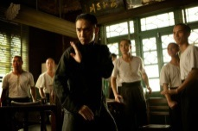
Running at 2 hours and 10 minutes in its world premiere at the Berlin Film Festival, Wong Kaw-wai’s dreamy biopic of martial arts master Ip Man was cut by 22 minutes — one-fifth of its running time — by U.S. distributor The Weinstein Company. That’s a crime akin to cutting random holes in a Bosch or Breughel painting; but what’s left is choice.

4. Her
In a future Los Angeles so near-Utopian that no scene takes place in a car, Theodore Twombly (Joaquin Phoenix) has a job composing love letters for other people. Profligately romantic, bruised by the failure of his marriage to Catherine (Rooney Mara), he has enough sentiment left over to fall truly, madly, deeply in love with a computer operating system who calls herself Samantha (Scarlett Johansson). Their virtual affair might be the springboard to satire, but writer-director Spike Jonze instead creates a splendid anachronism: a modern rom-com that is laugh-and-cry and warm all over, totally sweet and utterly serious. Or, if you will, utterly Siri. Phoenix corrals the dulcet melancholy of a man whose emotional pain finds refuge in Samantha’s embrace, in a love that, to misquote Phillip K. Dick, is “more human than human.”

3. American Hustle
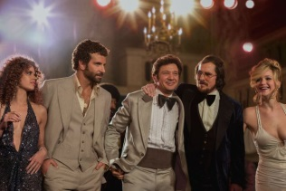
History remade as sparkling farce: the FBI’s late-70’s Abscam investigation of political corruption, which led to the conviction of a U.S. Senator and seven Congressmen, becomes this headlong tale of romance and recklessness.

2. The Great Beauty / La grande bellezza
This profligately cinematic achievement shows affection for nearly all of its outsize characters, and a melancholy that the flaming creatures of Jep’s acquaintance will soon burn out. Giving even the cynics a faith in the vibrancy of movies, The Great Beauty is the year’s grandest, most exhilarating film that takes place on Earth.

1. Gravity
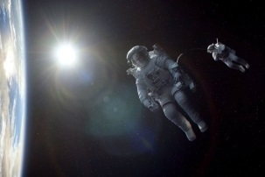
When NASA travelers Sandra Bullock and George Clooney get lost in space, all awe breaks loose. Losing contact with Mission Control, as well as access to their oxygen supply, they are alone together, with time and options running out. An epic of desperate peril and profound wonder, Alfonso Charon’s thrilling 3-D drama is a testament to human grit and groundbreaking technical ingenuity

By Isaac Stopeck

